**Assignment – Analytics & Data Visualization using Tableau**

Tableau is a recognized leader in data visualization and has a wide variety of customers from smaller organizations to fortune 500 companies. For a company profile, the Website for Tableau is <http://www.tableausoftware.com/>.

The example in this document illustrates a few of the many visualization features available using Tableau and data for airplane bird strikes. To use their software for instruction purposes, Tableau partners with Teradata University Network (TUN) and provides multiple options for faculty and student use including a free trial download and free access to Tableau Desktop.

Login to Teradata University Network (<www.teradatastudentnetwork.com>) and hover your mouse over SOFTWARE as shown below. Note that Tableau is in the Downloadable column.

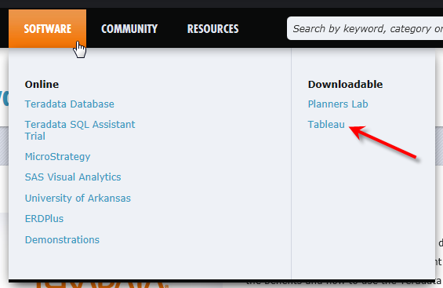

Click Tableau and then the Learn More button which takes you to the Tableau website. From the Tableau Website: <http://www.tableausoftware.com/>academics, click the Free Access to Tableau Desktop as shown below. You also have the option of downloading a Free Trial version.



You will be asked to unlock your free student copy of Tableau by providing information. Follow any instructions for registration and acitivation.

There are a number of sample spreadsheets downloaded with your free Tableau Desktop. On the Tableau Website (<http://www.tableausoftware.com/learn/training>), there are short videos that can be helpful. I recommend viewing the first video, Getting Started.

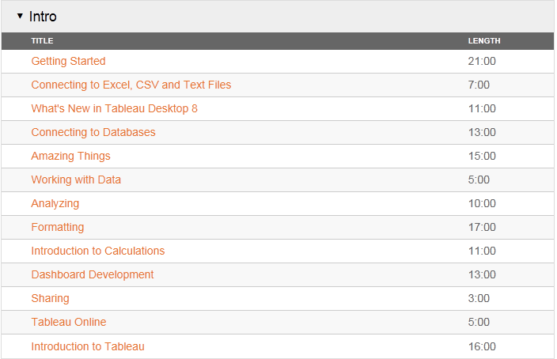

Tableau works with spreadsheets and the spreadsheet used for the assignment is named BirdStrikes.xlsx which you can download from TUN. The spreadsheet contains records of US flights between the years 2000 and 2011 where the plane has been struck by a bird while in flight.

In the Upper left, click on Connect to Data. Notice there are many, many options for data.

Click Microsoft Excel which opens the traditional Open file dialog. Locate where you have the BirdStikes.xlsx file and then select the Open button.

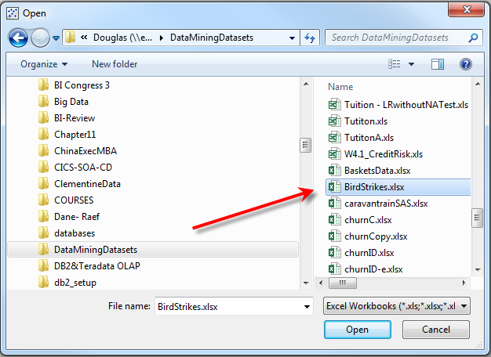

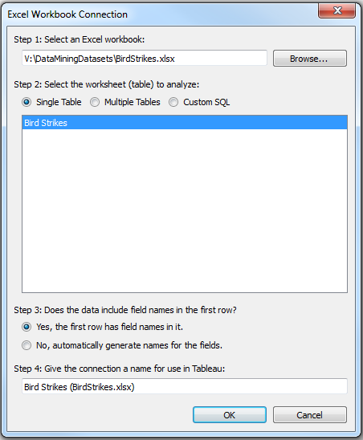

An Excel Workbook Connection Dialog will open with default options.

Step 2 allows a single table or multiple tables as well as Custom SQL. The default, Single Table, will be used for this illustration.

Step 3 allows use of the first row as field names or to generate field names if they do not exist. The default of using the first row for field names will be used in this illustration.

Step 4 allow giving the connection a name to use in Tableau. Bird Strikes (BirdStrikes.xlsx) is used for this illustration.

Click the OK button.

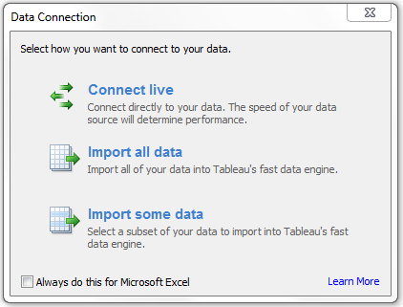

The Data Connection dialog appears with three options. The Import all data is the best option if your computer has enough memory to hold all the data whereas Connect live will be the slowest option. Try the Import all data option.

A Save As dialog allows you to save the Tableau extract as shown below. Save the data extract. The data will be imported into the Tableau workspace.

Tableau now opens with a workspace as shown below.

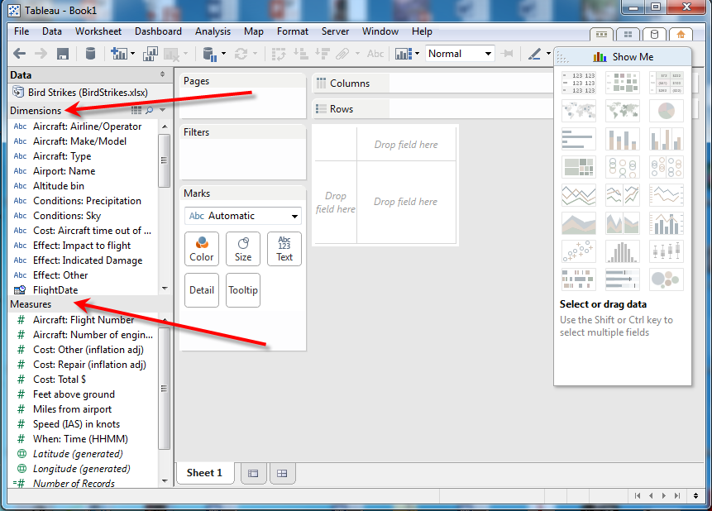

Take a few minutes to view the workspace. The left has dimensions and measures and the upper right has various graph options entitled Show Me. Notice the workspace has options for rows, columns and filters and works in a similar manner as an Exel Pivot Table. The Show Me in the upper right allows the user to select different visualizations—and it is a toggle. Click Show Me to remove the drop down from the workspacel—click Show Me to redisplay the drop down.

The idea is now you have a workspace that allows quick analysis to support decision making. Any number of ad hoc questions should be able to be answered. As an example, consider the following question.

Question 1. Which departure state has the highest total monetary costs as a result of bird strikes?

Double-click on **Origin State** in Dimensions and then double-click on **Costs: Total $** in Measures Panel to get the results shown below.

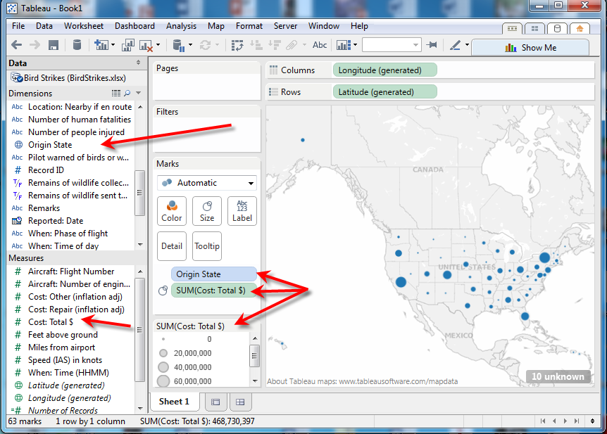

Note the intuitive approach here of the larger dots having higher totals costs as a result of bird strikes. Also note in the Marks pane the Sum(Costs: Total $). Sum was the default—one can right-click, select measure and change to another operation such as average.

Also note by moving your mouse over the dots, exact values are displayed.

Question 2: What is the average speed for the airplanes with bird strikes from the states of origin? Double-click the Speed (IAS) in knots. In the Marks panel, right-click the Sum(Speed …) and change the Measure of Sum to Average. See below.

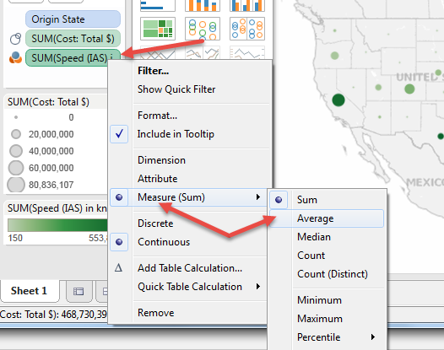

The results are shown below.

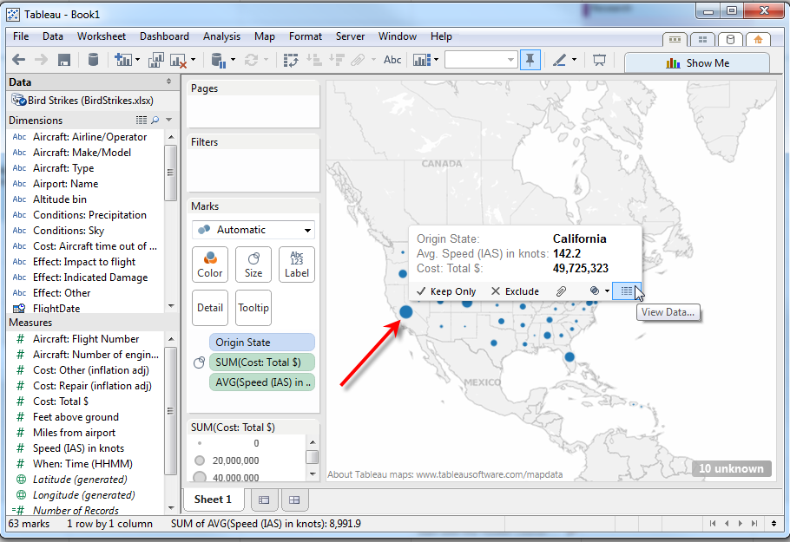

Again, size of the dots show the relative speed with larger dots have a higher speed than smaller dots. The average speed for California is 142.2 with a total cost of bird strikes being is 49,725,323. Note that entries in the Marks pane can be removed by right-clicking them and selecting Remove.

Question 3: How does the results change if the dimension “Aircraft Make/Model” is added? Drag Aircraft Make/Model to the Details box in the Marks pane. Now, when you move the mouse over one of the dots, the make/model of the aircraft has been added to the information. As shown below, the Airbus A320 is the model/type of aircraft.

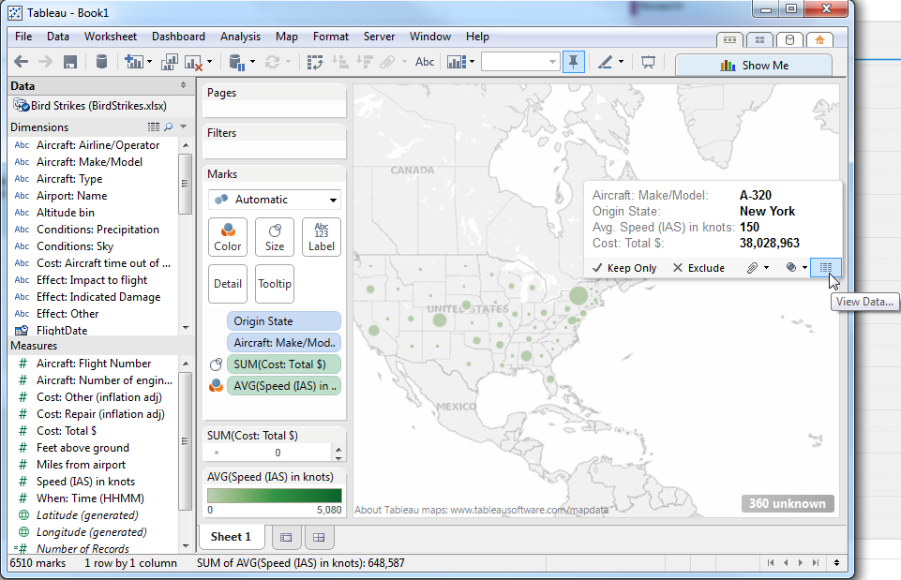

To determine the impact of these strikes on the bird population in terms of total cost, click on the next sheet at the bottom to the right of Sheet 1—that is Sheet 2.

Add the Sum(Costs: Total $) to the columns and Wildlife species to the rows on this worksheet. Then, click the Sort descending sequence icon on the toolbar to get the following. Note that Time of Day is also a dimension that could be added to the chart (not shown)

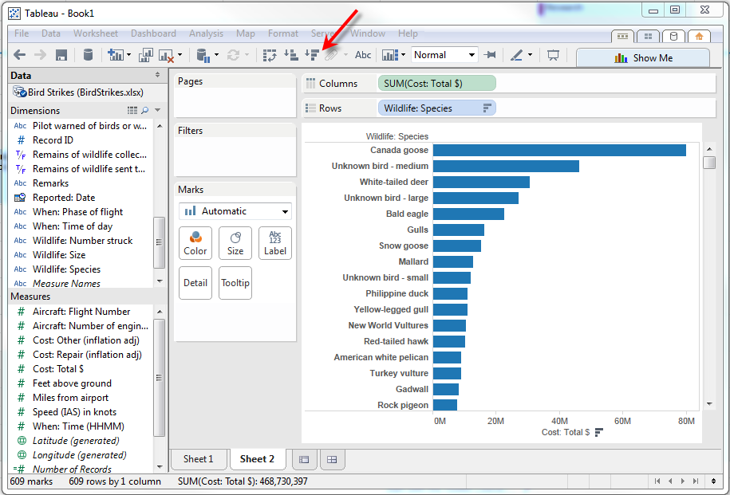

Drop the #Number of Records on the Color Tool and then click on the packed bubbles try on the Show Me List.

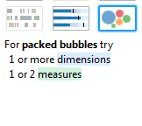

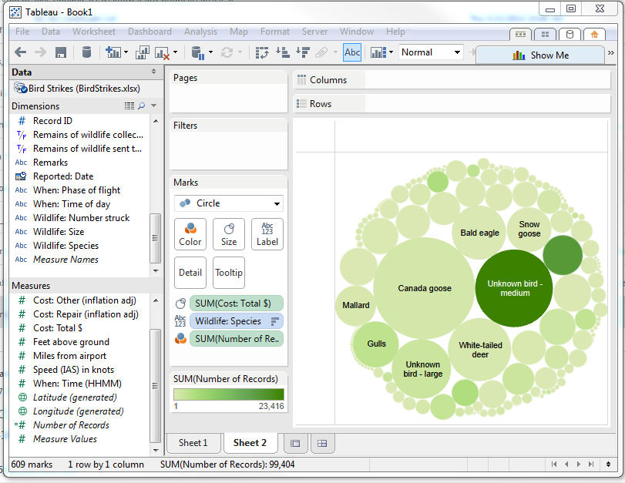

Note the image above is not full-screen so it is readable. When expanded to full-screen, additional names of birds will appear in the bubbles that are large enough to hold the text.

You may find the packed bubble chart not be all that useful for this particular application. Thus, click the back arrow (upper left) to return.

To reduce the number of bars, add a filter to have the range of the total costs to have a minimum of 10,000,000 instead of 0. To do this, right-click on the SUM(Cost:Total$) in the Columns entry or use the drop-down box to the right of SUM(Cost:Total$) in Columns.

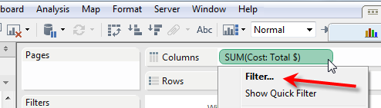

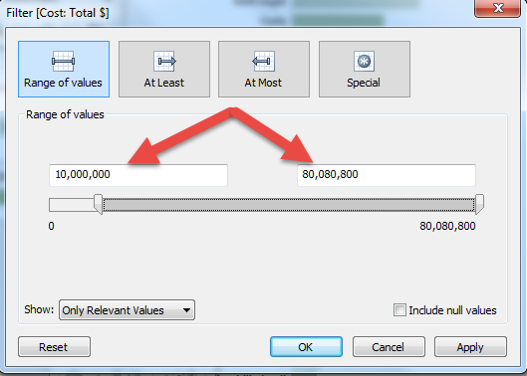

The resulting list is shown below.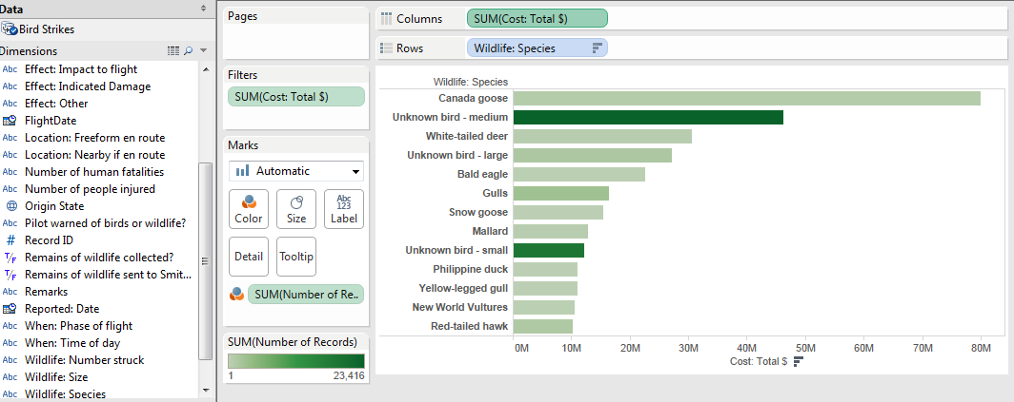

We can change the color format by selecting the arrow next to the SUM(Number of Records) and selecting Edit Colors—then use the Palate drop down to select Red-Green Diverging as shown below. Also, click the Advanced button—change settings as shown and click apply. Then click the OK button to see the resulting changes. Save the file with the two sheets.

